Part 2: Design materials
Your design materials should give a reader a clear, high-level understanding of the product you will deliver: what it is, who uses it, what it does, and how it is put together. Breadth matters more than depth here — cover the whole product at a high level rather than one piece in detail.
Projects differ, so choose the artifacts that best communicate your product. Every team must include the three required items below, plus at least two from the menu.

Required (all teams)
- Product overview (1 page). A plain-language description of the product, its users, and the problem it solves. A client should be able to read this and say "yes, that's what we asked for."
- Key features or capabilities. The main features, each linked to a requirement or objective in your charter. Mark each as must-have, should-have, or could-have.
- High-level structure. One diagram showing the major parts of the product and how they connect — for software, a system or architecture diagram; for other products, a block diagram, component breakdown, or process flow.

Menu (choose at least two)
Artifact | Best for | What to include
Wireframes or mockups | Products with a user interface | The 3–6 most important screens, with navigation between them
User flow or journey map | Products with multi-step processes | The main path a user takes from start to goal
Application architecture | Software applications | Application layers and components (UI, services, data stores), how they interact, and key external integrations
Network diagram | Systems spanning multiple hosts, devices, or environments | Servers, devices, network segments, and connections, including where each component is hosted and how users reach it
Data model or ERD | Data-heavy systems | Main entities, key attributes, and relationships
Interface or API outline | Integrations, services, hardware with interfaces | Main inputs and outputs and the systems they connect to
Physical design sketch or CAD | Hardware or physical products | Form, major components, and dimensions where known
Technology stack and rationale | Software products | Chosen languages, frameworks, platforms, and hosting, with reasons
Prototype or proof of concept | High-risk or unfamiliar technology | A small working demo of the riskiest piece, with a short write-up of what you learned
User stories and detailed requirements belong in your team's requirements document, not here. Link to it from your Design wiki page: [link to requirements document].

Design decisions and open questions
Close with a short section (about one page) that lists:
- The 3–5 most significant design decisions you have made and why.
- Alternatives you considered and rejected.
- Open design questions you still need to answer, and when on your roadmap you plan to answer them.

Example: LabLink equipment booking
Design: product overview
Today, lab bookings run on paper sign-up sheets and email. That causes double-bookings and leaves the lab manager with no usage data for budget requests. LabLink replaces both with one place to see what's available, book a time slot, and get reminders, while giving lab managers approval control and usage reports.
Users: students (book equipment), lab managers (approve bookings, manage the catalog), and the department administrator (reads usage reports).
Design: key features
Feature | Charter objective | Priority
Sign in with campus SSO | 1. Secure access for enrolled students | Must
Equipment catalog with live availability | 2. One place to find equipment | Must
Book, change, or cancel a time slot | 2. One place to find equipment | Must
Manager approval for restricted equipment | 3. Lab manager control | Must
Email reminders and no-show tracking | 4. Fewer no-shows | Should
Usage reports by lab and item | 5. Usage data for budget planning | Should
Waitlist for fully booked items | 4. Fewer no-shows | Could
User stories and acceptance criteria are on the team's requirements wiki page: [link to requirements page].
From the menu, this team chose an application architecture and a network diagram, shown below. They also included wireframes and a data model, not shown here.
Design: application architecture
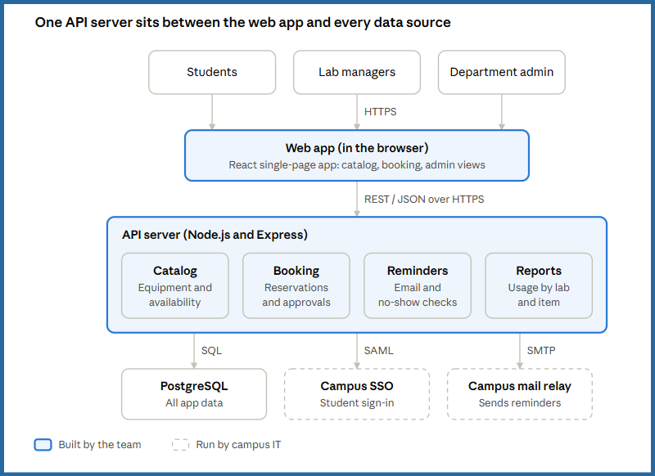
All three user types use the same web app; the API server holds the business logic and is the only part that talks to the database, campus SSO, and the mail relay.
Design: network diagram
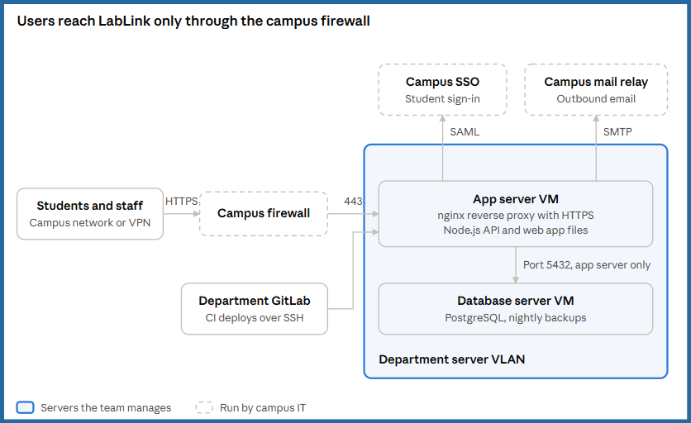
Only port 443 is open from the campus network; the database accepts connections from the app server alone, and GitLab CI deploys new versions over SSH.
Design decisions and open questions
Decisions
- Web app, not a mobile app. Every student has a browser, and one codebase fits a two-semester build. Rejected: native iOS and Android apps.
- Campus SSO, not LabLink accounts. No passwords to store, and enrollment comes from the university. Rejected: email-and-password accounts.
- Department-hosted VMs, not cloud hosting. Department IT can support it after the team graduates, at no ongoing cost. Rejected: a commercial cloud host.
Open questions
- Do restricted items need instructor approval as well as lab manager approval? Resolve with the client by the end of Discovery.
- Can SSO tell us which courses a student is enrolled in? The October SSO spike answers this.

